**Proposal Title**: ***In-situ analysis of surface chemistry on model 2D materials***

A proposal for SONY Faculty Innovation Award

PI: Yong. P. Chen (Email: [yongchen@phys.au.dk](mailto:yongchen@phys.au.dk), Tel: +45 50184112)

Department of Physics and Astronomy and the Interdisciplinary Nanoscience (iNano) Center,

Aarhus University, Aarhus-C, 8000 Denmark

Research Area/Category: Devices and Materials --- Analysis/Simulation/Informatics

**Key Word**: In-situ Analysis of Surface Chemical Reactions

Optional PI keywords: surface analysis; surface chemistry; Raman spectroscopy; infrared spectroscopy; AFM (atomic force microscopy); STM (scanning tunneling microscopy); two-dimensional (2D) materials; glovebox; oxidation; air-sensitivity

1. **Abstract**

We describe a research program to study *in-situ analysis of surface chemical reactions* enabled by a unique set of state of art experimental facilities the PI has recently established in a new lab at Aarhus University, Denmark. The facilities include a cluster of 3 interconnected gloveboxes (so called “*lab in gloveboxes*”) inside which one can perform 2D materials fabrication/transfer, optical Raman/IR spectroscopy, and AFM-based multimodal scanning probe microscopy (SPM) in controlled environment (gas exposure). The facilities also include a multiple-chamber scanning tunneling microscope (STM) where samples can also be subject to various controlled environment. In the first year, we will focus on demonstrating the capabilities of this cluster facility to perform in-situ analysis of surface chemical reactions, *using 2D materials as a versatile model system* to study the *oxidation and air-degradation of air-sensitive 2D materials* (such as various transition metal chalcogenides and halides). The work and facilities will enable many further studies of in-situ chemical reaction and catalysis on materials surfaces.

1. **Motivation**

The advent of atomically thin two-dimensional (2D) materials such as graphene and transition metal dichalcogenides (TMD) have attracted strong interests in materials sciences and nanoscience, and also have proven to be excellent candidates for wide applications such as photo-detectors, optoelectronics, memory storage devices, high-performance transistors, low-loss electrical and thermal conductors, and strain sensors to name a few [1]. Their rich properties can also be highly tunable by thickness (number of layers), temperature, strain, electrical gating, magnetic field, and chemical environment and treatment. Depending on the type of transition metal and chalcogen, the electrical, structural, magnetic, optical and topological properties vary drastically. Also, one atomically thin monolayer of these materials can be stacked onto another, which gives rise to some further unique properties. For large-scale industrial applications, many of these materials can be grown using chemical vapor deposition [2]. However, some of the members of the TMD and halides family such as NbSe2, CrX3 (X=Cl, Br and I) and WTe2 (examples of 2D superconductor [3], magnets [4] and semiconductor or topological metal [5], respectively, with promising applications in nanoelectronics, spintronics, and quantum technologies) are air sensitive. An understanding of their chemical properties and changes, when exposed to different gases (air, O2, H2O vapor etc.), will help to realize their applications in the near future. Two-dimensional (2D) materials, with their exposed surface, make them both easily subject to chemical interactions and reactions with environment, and also particularly amenable to have their physical and chemical properties carefully characterized by multiple probes (down to atomic details), therefore offering an excellent model system to study in-situ chemical reactions on surfaces.

1. **Experimental Facilities and Methods**

Below we describe two key sets of experimental facilities recently commissioned in PI’s lab to be used in this study --- the interconnected “labs in gloveboxes” facility, and a scanning tunneling microscope (STM) system.

**Interconnected Glovebox System with Inert Environment (< 1 ppm of O2 and H2O)**

Our group has set up three interconnected glovebox systems (from Jacomex) capable of holding inert (N2) atmosphere in either overpressure or underpressure conditions with an autonomous purification unit continuously maintaining <1 ppm O2 and H2O under normal operating conditions. They allow (with purification units off) intentionally introducing controlled amounts of gases (e.g. O2, H2O, CO2) in the default N2 atmosphere, creating various controlled-gas/exposure environment to study material/surface chemical processes. The individual gloveboxes are designated and configured for 1) micromechanical exfoliation and stacking of 2D layered materials, 2) characterization via optical spectroscopy techniques such as Fourier Transform Infrared (FTIR) spectroscopy and Raman and Photoluminescence (PL) spectroscopy, and 3) surface probes such as atomic force microscopy and related techniques, respectively and described in more detail below. They are equipped with antechambers for the safe and efficient transfer of air-sensitive samples between themselves, without further exposure to ambient. The valves between them allow each glovebox to be individually isolated and controlled with different environment when needed.

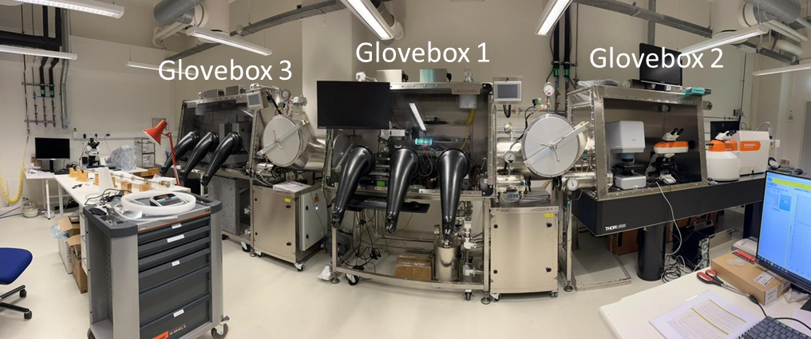

Figure 1. “Lab in Gloveboxes” – our 3 interconnected gloveboxes for 1) 2D material fabrication and transfer; 2) optical Raman and FTIR spectroscopy; and 3) Atomic force microscopy (AFM) and other related scanning probe microscopies (SPM).

**Glovebox 1: Two-dimensional (2D) materials fabrication and transfer setup**

This glovebox contains a setup to perform scotch tape based micromechanical exfoliation of van der Waals (vdW) layered 2D materials. It has a motorized micromechanical transfer setup (from HQ Graphene, Fig. 2a) equipped to stack layers in a wide variety of alignments and orientations. The substrate can be moved relative to the transparent stamp on the mask holder in X-, Y- and Z-directions and also has rotational degree of freedom. This allows for accurate alignment of 2D crystal flakes during heterostructure fabrication that can be used to create “Moire/twisted” structures with controlled twisting angle (which could tune material physical or even chemical properties that we intend to study later). The substrate is held by vacuum and the temperature can be controlled between room temperature and 200 °C. Its compact design allows it to be placed inside a glovebox, allowing us to work with air-sensitive 2D materials. The setup is equipped with a high-resolution microscope with long working distance objectives allowing for both bright field and dark field illuminations. Fig. 2b shows an example of an exfoliated/stacked monolayer h-BN/graphite/BN structure fabricated in this setup.



Fig. 2. (a) Motorized transfer setup inside glovebox. (b) A heterostructure composed of monolayer (1L) boron nitride (BN), graphite, multilayer BN (from top to bottom, as illustrated in the inset) on SiO2/Si++ wafer.

**Glovebox 2: Optical (Raman and FTIR) Spectroscopy**

Raman and Fourier-transform infrared (FT-IR) spectroscopy are two widely used nondestructive analytical tools to study vibrational properties down to micrometer scales of spatial resolution. As a vibrational mode can be either Raman or infrared active, the two techniques are complementary and provide a complete picture of the photon-phonon interaction in the system. Notably, the vibrational frequencies of each chemical bond are different and their spectral features act as a unique fingerprint for the compound. Importantly, *any chemical reaction and changes in structure can be systematically studied* using these techniques [6, 7]. Additionally, information such as *bonding type, reaction rates and defects, and their evolution with external factors* such as heating and laser irradiation can also be determined [8–10].

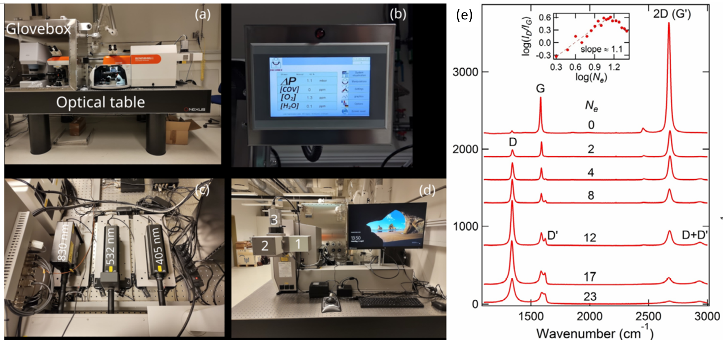

Figure 3: (a) Picture of the Raman instrument showing two microscopes with scanning stage in all three directions. One of the stages resides inside the glove-box for air-sensitive or controlled-environment measurements. (b) Data from the nearby glovebox shows the pressure (ΔP), oxygen and water contents inside in parts per million (ppm) unit. (c) Three lasers for studying effects from different excitation energies. (d) Three Peltier cooled CCDs (labeled by 1, 2 and 3). CCD1: 50 % enhanced quantum efficiency from 450 to 900 nm range. CCD2: Visible range detection. CCD3: InGaAs array detector for operating from 600 to 1700 nm range. (e) Raman spectra previously measured in Chen lab in a single-layer graphene (on SiO2/Si) after various numbers of accumulated oxygen plasma exposure pulses, *Ne*. The spectra are offset vertically for clarity. From Ref. [11].

Fig. 3(a) illustrates the Raman instrumental setup (Renishaw) with two different microscopes with spectral capabilities along and perpendicular to the sample surface. Using a software feature called focus tracking, spatial mapping can also be done on uneven and curved surfaces. One of the confocal microscopes is for ambient measurement and another one, placed beside the FTIR setup, is optically coupled with the spectrometer for air-sensitive/controlled environment measurement inside the nitrogen glovebox (Jacomex),

An example of the pressure, oxygen, and water content readout values of the glovebox is shown in Fig. 2(b). To examine samples with different band gaps or excitation energy ranges, three excitation lasers of wavelengths 405nm, 532nm and 830nm (Fig. 3(c)) are available. The spectrometer consists of three switchable gratings (1200, 1800 and 2400 lines per mm) and three thermoelectrically cooled charge-coupled device (CCDs) detectors (Fig. 3(d)) that are sensitive to visible and infrared wavelength ranges. In addition to edge filters for high-frequency Raman measurements, a notch filter is available for 532 nm laser excitation for Stokes/Anti-Stokes measurements, with a low energy filter to enable ultra-low frequency Raman measurements (∼ meV or <10 cm-1). As inter-layer vibrational modes can be detected in this energy range, the instrument can determine layer number, changes in stacking configuration and inter-layer bonding strength. Also, linear and circular polarization-resolved measurements can also be performed for all three lasers. Fig. 3e shows an exemplary previous study from PI’s group (measured in an earlier Raman instrument), using systematic evolution of Raman spectra to monitor how graphene undergo chemical (e.g. oxidization) and structural (e.g. amorphorization, vacancy generation) changes when it is subject to repeated O2 plasma exposure (commonly used as an etching tool) [11].



Figure 4: (a) FTIR setup (outside the glovebox) with joystick-controlled scanning stage in all three axes. (b) Optical micrograph of a multilayer hBN flake and (c) its IR spectrum peak corresponding to the B-N bond stretching.

The FTIR instrument (Bruker corporation LUMOS) can measure the reflectivity, transmission and absorption spectra of 2D materials down to μm level (Fig. 4(a)). The spectral range is from ∼ 1600 to 15000 nm, offering a versatile coverage of the infrared response spectrum for most materials. As shown in Figs. 4(b) and (c), FTIR spectrum of hexagonal boron nitride (hBN) of few μm’s in size have been captured. The FTIR and Raman setups are currently in the process of getting fully integrated inside the glove box.

**Glovebox 3: Atomic Force Microscope**

In glovebox 3 we have an atomic force microscope (AFM) (Asylum Cypher S, Fig. 5a) which is a fast-scanning AFM compatible with a range of scanning probe microscopy (SPM) modes and accessories. The standard operating modes available in our Cypher system are:

1. a. ***Contact mode AFM*-** AFM imaging technique whereby the AFM tip tracks the topography of the sample by monitoring the cantilever deflection.
2. b. ***Tapping mode (AC mode)-*** The cantilever is typically oscillated mechanically by a small piezo electric actuator and the drive frequency is swept to locate the first resonance of the cantilever. The drive frequency is then set at or near that resonance frequency. The optical detector senses the oscillatory motion of the cantilever and the electronics inside the controller measure the amplitude and phase of this oscillation with respect to the drive signal.
3. c. ***Electrostatic Force Microscopy (EFM)-*** EFM provides information on the local electrostatic forces between the tip and the sample which leads to a shift in the phase lag of the mechanically driven cantilever.
4. d. ***Scanning Kelvin Probe Force Microscopy (KPFM*)-** Scanning Kelvin Probe Microscopy (SKPM) is a technique that detects the potential difference between the probe tip and the sample.
5. **e. *Lateral Force Mode (LFM)-*** A specialized mode of Contact Mode AFM, LFM can tell how much the cantilever twists from the friction experienced by the tip during scanning. This signal is measured by the same quadrant photodetector that measures the cantilever deflection, except that “left” and “right” halves of the photodetector are subtracted to give the lateral deflection (twist) of the cantilever. Fig. 5b shows an example of *atom-resolved lattice image* of graphite measured with LFM using our Cypher AFM. We have also obtained atomic lattice images on h-BN.

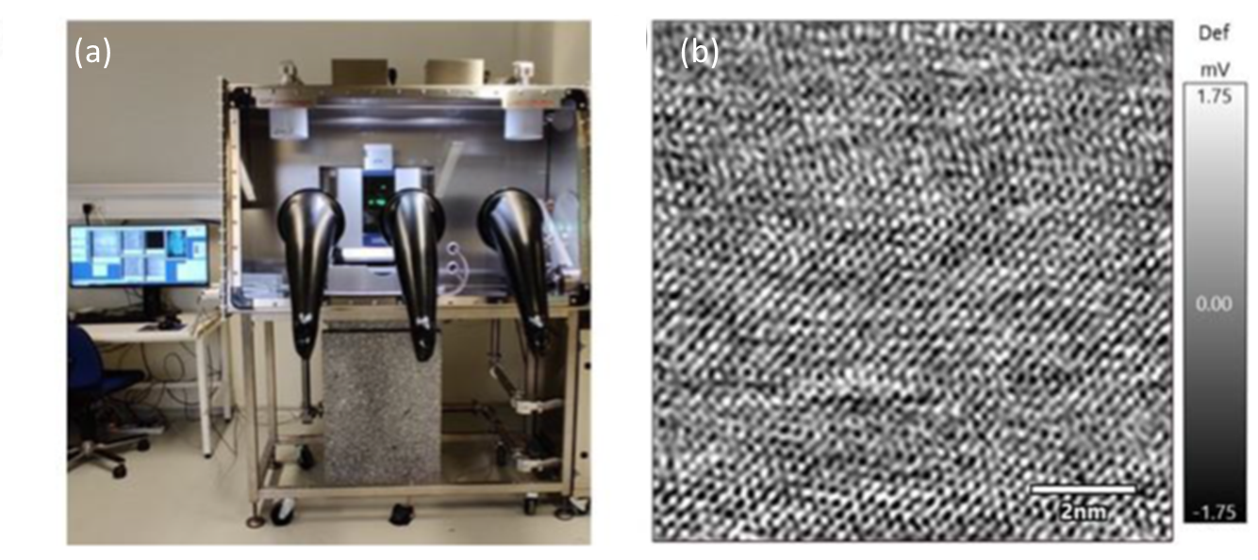

Fig. 5. (a) Cypher S AFM inside glovebox with control unit adjacent to it. (b) Lateral force microscopy (LFM) image showing atomically resolved lattice of highly oriented pyrolytic graphite (HOPG) obtained using Cypher S AFM.

**g**. ***Piezoresponse Force Microscopy (PFM)-*** PFM measures the mechanical response when an electrical voltage is applied to the sample surface with a conductive AFM tip. The sample deforms in response to the applied voltage, which in turn, causes the cantilever to deflect, which can then be measured and interpreted in terms of the piezoelectric properties of the sample.

1. Additionally, we have two optional specialized modes-
2. **h. *Conductive AFM (CAFM) with ORCA™-*** Conductive AFM or CAFM provides a map of the local conductivity of a sample at a fixed bias.
3. i. ***High voltage PFM*-** The high voltage PFM option allows users to conduct PFM measurements at high biases of up to ±150 V.
4. It is well known that AFM-based methods are widely used to measure the mechanical properties of materials but additionally, advanced AFMs such as our Cypher AFM have specialized modes which can be harnessed in the study of various chemical properties, catalytic and functionalization reactions on the surface of materials. For example, people have studied catalytic processes using in-situ AFM imaging down to single-molecule resolution [12]. They observed spontaneous formation of methanol–water structures on the surface of highly oriented pyrolytic graphene (HOPG), with the catalysis rate enhanced by electric fields. Meanwhile, another group used high-resolution AFM imaging to monitor the self-assembly dynamics of 1D peptide crystals on the surface of MoS2 and observed 2D arrays growing one row at a time, a result in line with the principles of classical nucleation theory [13]. AFM can also be used to study rate of etching reactions such as that of silicon (Si) by plasmas containing different percentages of sulfur hexafluoride (SF6) [14].
5. **Scanning Tunneling Microscope (STM)**

STM has played a crucial role in the research field of surface science and condensed matter. The STM system recently commissioned in our lab (Figure 6a) is a state-of-art ultra-high-vacuum (UHV) low temperature scanning tunneling microscope (LT-STM) (from Unisoku) allowing imaging, manipulation and tunnelling spectroscopy at the atomic level. It provides great opportunities *for in-situ* studies of on-surface reactions, as well as the underlying physics. Our newly installed Unisoku STM system is equipped with a few world’s most advanced capabilities for studying reactions. The system has several separate chambers (preparation chamber and exchange chamber, which is further equipped with a stage that can cool down the sample with liquid helium) that can be routinely connected to a variety of gas lines, such as H2O, O2, H2, CO or CO2 providing means for well controlled reaction studies with individual or mixture of gases, before the sample is transferred to STM for in-depth atomic-level studies. Atomic C, H and O crackers are available for studies involving reactions induced by radicals which may include controlled generation of defects at surfaces or synthesis of larger molecules. Finally, the attached metal and molecular evaporators allow us to investigate the growth of epitaxial layers but also to study e.g. molecular self-assembly as a function of surface temperature and the type of the surface. Controlled deposition down to 20K is possible. Further specific features of the system include:

1. ***Ultra-low temperature and high magnetic field***

The STM system can be operated down to temperature of 300 mK and up to a magnetic field of 16 T (perpendicular to sample surface). The ultra-low temperature, together with the atomic-resolution microscopy and spectroscopy provides an excellent platform for studies of a variety of inter-molecular reactions, in particular on weakly bound surfaces such as graphite or graphene. Additionally, one can determine preferential adsorption sites; image the orientation of the molecule on the surface; follow the diffusion on the surface; image molecular orbitals and consequently induce particular reaction by injecting the tunnelling electrons into the specific orbital to study *site-selective chemistry*. The *state-of-the-art in STM induced reactions* include both the site selective bond rupture as well as synthesis of a new molecule via bond formation [15]. On the other hand, the capability of applying high magnetic field opens opportunities for new type of selective reactions, such as magnetic field induced ordering of magnetic molecules, synthesis of larger molecules from the individual magnetic constituents, and novel synthesis controlled by magnetic fields or on magnetic substrates.

1. ***Study of cleaved air-sensitive samples***

The STM system contains a sample preparation chamber with a base pressure at 10-10 mbar, which is important for the air sensitive samples. The chamber can also be connected with various gas lines to intentionally induce chemical reactions to the sample if needed. For samples that cannot be cleaned by standard Ar+ sputter/anneal cycles, the system is equipped with a cleaving stage allowing us to break the sample in UHV and thus obtain a clean pristine surface. Sample cleavage is also possible at temperatures down to 20K as for some materials the cleaved surface may undergo phase transition at room temperature (RT) or may become rapidly contaminated due to the high reactivity at RT.

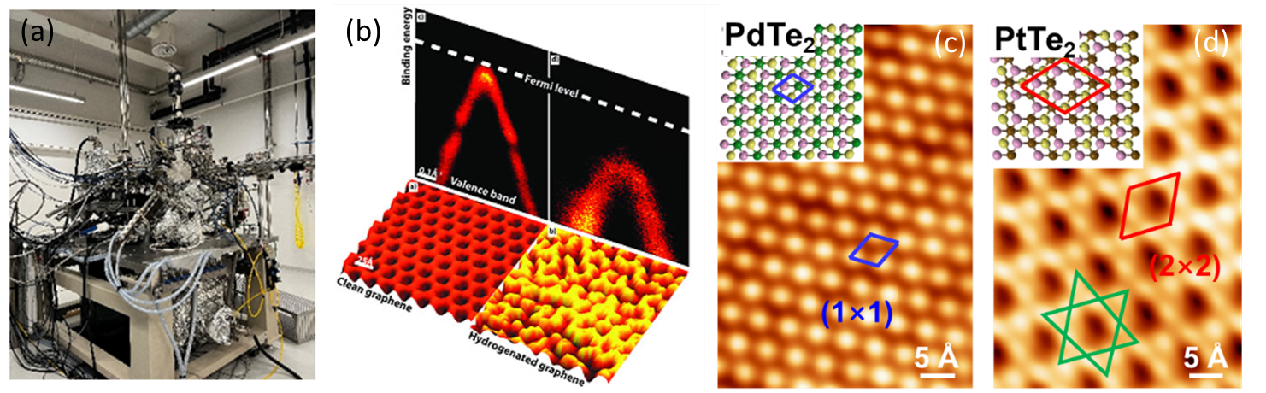

Figure 6. (a) Unisoku LT-STM recently installed and commissioned in PI’s new lab in Aarhus. Relevant examples from previous studies: (b) STM (lower) and ARPES (upper) data of CVD graphene grown on Ir(111) surface before (left) and after (right) surface-assisted hydrogenation. The STM data show topographic image while the ARPES data show band structure of graphene around the Dirac point. (c) Atomic-resolution STM images of monolayer PdTe2 and patterned PtTe2, formed after tellurization reactions of single crystal Pd and Pt surfaces.

We not that the PI’s group at Aarhus has two experienced group members, namely, Asst. Prof. Richard Balog and Postdoc Dr. Lina Liu, both having strong expertise in studying on-surface reactions by STM but also by other surface sensitive techniques (ARPES, XPS, LEED, HREELS) and both are presently available for reaction studies using Unisoku STM. They have strong prior background in multidiscipline research, especially in the field of surface chemistry and physics. For example, Balog is proficient in electron induced reactions in pure and mixed molecular ices, reactions induced by atomic species as well as on-surface synthesis of 2D layers by means of chemical vapor deposition (CVD) and molecular beam epitaxy (MBE). Notable prior works in surface reactions include - complete transformation of freon (C2F4Cl2) ice into Cl2 and Teflon through site-selective reaction [16], bandgap opening in monolayer graphene via surface-assisted hydrogen reaction (Figure 6b) [17] or surface assisted formation of ordered pattern of graphene quantum dots embedded in BCN layer [18]. Liu obtained a PhD degree of chemistry and is also an expert in surface chemistry reaction. A recent work by Liu with the PI reported the first synthesis of monolayer PdTe2 and patterned PtTe2 by direct tellurization of Pd(111) and Pt(111) surfaces (Fig. 6c) [19].

1. **Goals and milestones**

The main goal of the one-year (first year) research program is to study and characterize the air-reactivity (e.g. oxidation) of various air-sensitive 2D materials, using the experimental facilities and methods described above and demonstrating their capabilities and suitability to perform in-situ analysis of surface chemical reactions, paving the ways for many further studies of surface chemical reactions in future years on other technologically important materials (including a larger variety of 2D materials).

a) More specifically, to study the exposure effect of gases in air-sensitive 2D materials such as NbSe2 (whose degradation/oxidation behavior as an air-sensitive 2D material has been little studied) and CrX3. Their flakes (monolayer, bilayers, few-layers including twisted bi/few-layers) will be micro-mechanically exfoliated or stacked inside the glovebox 1. Using the anti-chamber connection in between the gloveboxes, they can be transferred into glovebox 3 where the thickness characterization can be performed by atomic force microscopy (AFM). The samples will be transferred to glovebox 2 for FTIR and Raman spectroscopy/microscopy. Here they will be exposed to controlled amount of air and other gases such as O2 and water vapor in a controlled manner using a small pressurized cylinder. The Raman and FTIR spectra will be recorded repeatedly with time lapses. By analyzing the spectral peaks, disorders, crystallinity, chemical bonding and chemical reactions in the samples will be thoroughly studied. Using spatial mapping in our scanning Raman and FTIR microscope, the location of different spectral features and their spatial distribution/inhomogeneity can be determined with ∼μm spatial resolution. For even more spatial resolution, different scanning probe methods such as conductive AFM (conductivity map), amplitude modulation-frequency modulation AFM (visco-elasticity measurements of mechanical properties) and Kelvin probe AFM (work function/potential map) can be employed using our Cypher AFM on samples transferred to glovebox 3, with controlled gas exposure and different time lapses.

b) We will also use our STM to perform further and complementary investigations on the above air-sensitive materials which (as required by STM measurements) are sufficiently conducting (TMDs such as WTe2 or NbSe2, although monolayer insulator CrX3 on conducting substrate could still be explored). We will first transfer the sample into the preparation chamber --- either cleave a fresh surface there (using a corresponding bulk layered crystal, to study chemical reactivity of the surface), or transfer a fresh-exfoliated few-layer flakes (produced in glovebox 1 on conducting substrates with a pre-fabricated spiral-pattern as “tip guide” to facilitate locating the small-size 2D material flakes in STM; transfer of the air-sensitive flakes from the glovebox to STM will be done using air-tight connections such as “vacuum suitcases” interfaced with the STM chambers). After such as fresh cleaved/transferred sample is in place in the preparation chamber, we will introduce a small and controlled amount of gas (e.g. O2) exposure through our gas lines/leak-valves. After the exposure/reaction for variable controlled time (alternatively we could also perform the controlled gas exposure/reaction in our exchange chamber/cooling stage under variable sample temperature to study the effect of lower temperatures on the surface chemistry, noting in the glovebox-based optical/AFM studies discussed the previous paragraph are done only at RT with limited heating possible), we will transfer the sample to the UHV LT-STM chamber for STM measurement (where sample can be held at RT or cooled to low T for higher resolution measurements). The goal is to obtain high-spatial-resolution (atomic-scale) characterization of the material/surface morphological, structural and even electronic (obtained by dI/dV tunneling conductance spectroscopy) properties and their spatial distributions before and after the controlled chemical reaction (gas exposure).

1. **Differentiation from the current state-of-the-art**

* Earlier studies of in-situ analysis of surface chemical reactions were mostly performed on metals (corrosion studies etc.), semiconductors, and battery materials etc. There are relatively few such studies on 2D materials, limited only to few examples.
* The limited recent studies on 2D materials [20,21] include just a few examples such as graphene [11,22,23], black-phosphorous [24], Bi2Se3 [25], TMDs [20,21, 26,27], CrX3 [28-31] etc. There are few or no studies on some of the material we are studying such as NbSe2. Even in the case where there have been a few recent studies such as on CrX3 (which exhibit rich photocatalytic chemistry) and TMDCs, there still lack systematic and *well-controlled* investigations, such as layer number-dependent studies (given the reactivity varies considerable with thickness going from one layer to bulk, and the chemical behavior of twisted/Moire homo and hetero bilayers remain rarely studied), temperature or photon energy dependence, and various important experimental probes (e.g. atomic STM studies remain rare).
* The combination of multiple complementary probes – the glovebox-based Raman/IR spectroscopies and AFM, and UHV-based STM – employed at the same time on the same material (esp. 2D materials, which conveniently lend itself to be studied by multiple surface probes and is a particularly versatile and informative model platform for in-situ studies of surface chemical reactions), is quite unprecedented and promise to yield many new insights and new experimental techniques for gas/material-surface reaction and surface chemistry.

1. **References**

[1] S. Manzeli, D. Ovchinnikov, D. Pasquier, O. V. Yazyev, and A. Kis, Nature Reviews Materials 2, 17033 (2017).

[2] N. Choudhary, J. Park, J. Y. Hwang, and W. Choi, ACS Applied Materials & Interfaces 6, 21215 (2014),

[3] A. Hamill, B. Heischmidt, E. Sohn, D. Shaffer, K.-T. Tsai, X. Zhang, X. Xi, A. Suslov, H. Berger, L. Forr´o, F. J. Burnell, J. Shan, K. F. Mak, R. M. Fernandes, K. Wang, and V. S. Pribiag, Nature Physics 17, 949 (2021).

[4] X. Cai, T. Song, N. P. Wilson, G. Clark, M. He, X. Zhang, T. Taniguchi, K. Watanabe, W. Yao, D. Xiao, M. A. McGuire, D. H. Cobden, and X. Xu, Nano Letters 19, 3993 (2019)

[5] P. Li, Y. Wen, X. He, Q. Zhang, C. Xia, Z.-M. Yu, S. A. Yang, Z. Zhu, H. N. Alshareef, and X.-X. Zhang, Nature Communications 8, 2150 (2017).

[6] M. F. Buehler and E. Davis, Colloids and Surfaces A: Physicochemical and Engineering Aspects 79, 137 (1993).

[7] Y. Wang, J. Xiao, H. Zhu, Y. Li, Y. Alsaid, K. Y. Fong, Y. Zhou, S. Wang, W. Shi, Y. Wang, A. Zettl, E. J. Reed, and X. Zhang, Nature 550, 487 (2017).

[8] C. L. Aardahl, J. F. Widmann, and E. J. Davis, Appl. Spectrosc. 52, 47 (1998).

[9] A. Eckmann, A. Felten, A. Mishchenko, L. Britnell, R. Krupke, K. S. Novoselov, and C. Casiraghi, Nano Letters 12, 3925 (2012)

[10] A. Rygula, K. Majzner, K. M. Marzec, A. Kaczor, M. Pilarczyk, and M. Baranska, Journal of Raman Spectroscopy 44, 1061 (2013)

[11] Isaac Childres, Luis A. Jauregui, Jifa Tian, Yong P. Chen, New Journal of Physics 13, 025008 (2011) (selected by NJP editors for inclusion in the 'Highlights of 2011' collection)

[12] Foster, William, et al., ACS applied materials & interfaces 10.40 (2018): 34265-34271

[13] Chen, Jiajun, et al. Science 362.6419 (2018): 1135-1139

[14] Arora, Priyanka, et al. Journal of Vacuum Science & Technology A: Vacuum, Surfaces, and Films 37.6 (2019): 061303.

[15] Florian Albrecht et al Science, **377**, 298-301 (2022)

[16]R. Balog, E. Illenberger**,** PRL, **91**(21), pp. 213201/1-4, 2003.

[17]R. Baloget. al. Nat. Mater., **9**, 315 – 319, 2010.

[18] L. Camilli, et. al., Nature Commun.**8**, 47, 2017

[19] L. Liu et al. 2D Mater. **8**, 045033 (2021).

[20] Q.Li et al. J. Mater. Chem. A, 2019,7, 4291-4312

[21] Wang et al 2019 2D Mater. 6 042001

[22] H.Y.Nan et al. J. Raman Spectr. 44, 1018-1021 (2013)

[23] E. Starodub et al. Phys. Chem. C 2010, 114, 11, 5134–5140

[24] W.Luo et al. Nanotechnology 27, 434002 (2016)

[25] D.Kong et al. ACS Nano 2011, 5, 6, 4698–4703

[26] F.Hou et al. ACS Appl. Electron. Mater. 2020, 2, 2196−2202

[27] F. Ye et al., Small 12, 5802 (2016)

[28] D. Shcherbakov et al. Nano Lett. 2018, 18, 7, 4214–4219

[29] T.Zhang et al. J. Am. Chem. Soc. 2022, 144, 12, 5295–5303

[30] D. Mastrippolito et al. Nanoscale Adv., 2021,3, 4756-4766

[31] Y. Wu et al. Materials 2022, 15, 3007.

1. **Budget Summary**

One-year budget of 100K USD (~750K DKK) will support: 1 graduate student (400K DKK), partial staff time (100K DKK), operating cost (200 DKK), travel (50 DKK). The numbers above include associated fees/overhead.